***DELFIA® Eu-N1 ITC chelate labeling Kit***

Catalog#: 1244-302



**INTENDED USE:**

This DELFIA® Eu-Labelling kit is intended for labelling of proteins with europium (Eu3+) for use in dissociation-enhanced time-resolved fluoroimmunoassays.

**INTRODUCTION:**

Each DELFIA Eu-Labelling kit contains:

- 0.4 mg Labelling reagent (Eu-N1 ITC chelate)

- Eu-Standard and Enhancement Solution for measuring Eu3+

- Stabilizer, purified BSA, for increasing the stability of labelled proteins

- An uncoated microtitration plate, DELFIA Assay Buffer and Wash Concentrate for testing of labelling results

Europium forms a highly fluorescent chelate with ligands present in the DELFIA Enhancement Solution. The long fluorescence life-time enables the use of the chelate in time-resolved fluorometry. The time-resolved principle is applied in fluoroimmunoassays to eliminate background interferences (1,2).

The Labelling reagent is the Eu-chelate of N1-(p-isothiocyanatobenzyl)-diethylenetriamine-N1,N2,N3,N3-tetraacetic acid (DTTA) (Figure 1) (3). The DTTA group forms a stable complex with Eu3+ and the isothiocyanate-group reacts with primary aliphatic amino group on the protein at alkaline pH to form a stable, covalent thiourea bond (Figure 2). The high water solubility and the stability of the chelate, in addition to the mild coupling conditions of the isothiocyanate reaction, enable easy labelling of proteins.

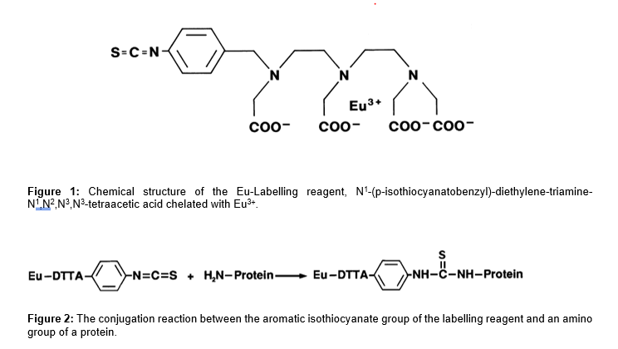

In order to use a simple gel filtration for fractionation of labelled proteins and separation of proteins from free Eu-chelates, the molecular weight of the protein needs to be at least 5000. For smaller peptides or other amine-containing compounds to be labelled, separate purification systems need to be specifically developed.

The thermodynamic stability of the chelate allows long-term storage of labelled proteins and the kinetic stability allows use of the labelled reagents in assays in contact with e.g. serum samples.

The labelled protein as such is practically non-fluorescent. Consecutively to the immuno-reactions and appropriate washing steps, however, Eu3+ is efficiently released from the chelate within a few minutes by the low pH of the Enhancement Solution. Free Eu3+ rapidly forms a new highly fluorescent chelate with the components of the Enhancement Solution (1,2). The fluorescence is then measured with the time-resolved fluorometer.

**KIT CONTENTS:**

The expiry date of the complete package is stated on the outer label.

**Reagents:**

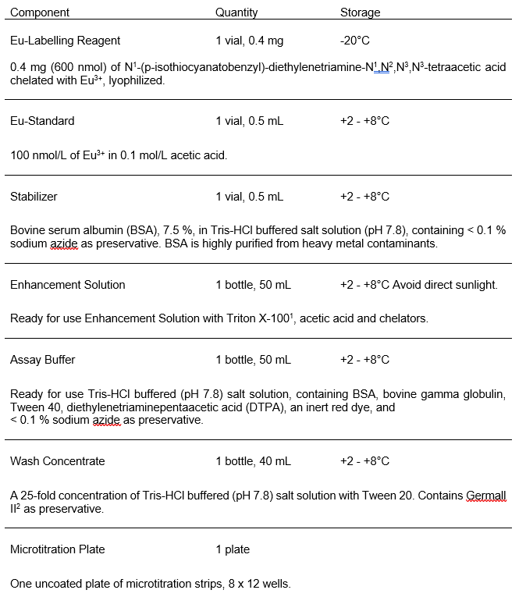

**MATERIALS REQUIRED BUT NOT SUPPLIED WITH THE KIT:**

1. Labelling buffer: 1 M aqueous NaHCO3/Na2CO3 buffer, pH ~9.3, to be diluted to 50-100 mM (10-20 X) in labeling reaction

2. Chromatographic system: Gel filtration columns for changing buffers for proteins prior to labelling (e.g. NAP-5 and PD-10 columns) and for purification and fractionation of labelled proteins (e.g. Superdex 200 column or a combination of Sephadex G-50 and Sepharose 6B columns ). Fraction collector, peristaltic pump, UV-detector and tubings.

3. Elution buffer: 50 mmol/L Tris-HCl (pH 7.8), containing 0.9 % NaCl and < 0.1 % NaN3.

4. Column decontamination buffer: 10 mmol/L potassium hydrogen phthalate (pH 4.0), containing 0.01 % diethylenetriaminepentaacetic acid (DTPA), and 0.1 % Germall II as preservative.

5. Precision pipettes: range 0.5 - 500 µL.

6. Spectrophotometer for measurement of protein concentrations.

7. Automatic shaker.

8. VICTOR™ Multilabel Counter.

**WARNINGS AND PRECAUTIONS:**

This DELFIA Eu-Labelling kit is intended for research use only.

The handling of concentrated Eu3+ solutions constitutes a contamination risk which may cause elevated backgrounds in time-resolved fluoroimmunoassays. Keep the labelling reagents away from the place where the assay is performed. Also ensure that accessories used for the labelling procedure are kept separate from those needed for the assay.

Reagents contain sodium azide (NaN3) as a preservative. Sodium azide may react with lead and copper plumbing to form highly explosive metal azides. On disposal, flush with a large volume of water to prevent azide build-up.

Disposal of all waste should be in accordance with local regulations.

**LABELING OF PROTEINS:**

Conditions for labelling

The labelling depends upon the nature and concentration of the protein to be labelled, the temperature and pH of the reaction, reaction time and the intended final labelling yield. The proteins to be labelled must be in a buffer that does not contain any amines or sodium azide.

The recommended conditions for labelling are the following: 50 -100 mM sodium bicarbonate/sodium carbonate buffer, pH 9 – 9.3, +4°C and overnight reaction.

Labelling yield

When labelling antibodies, generally about 6 - 12 Eu3+/IgG with monoclonal antibody is an optimal yield giving high sensitivity with low background. For many assays even a lower labelling yield gives acceptable results. For polyclonal antibodies the suitable number of Eu chelates coupled is 3 – 5. Labelling of antibodies with over 20 Eu3+/IgG may occasionally cause aggregation and an elevated background, especially after storage. Proteins with a lower molecular weight should be labelled with fewer chelates than for example monoclonal antibodies. Proteins with molecular weight 30-70 000 are preferably labelled with 2 – 6 chelates and proteins and peptides with molecular < 30 000 with 1 – 3 chelates.

The labelling yield needs to be optimized separately for each particular protein and the assay requirements. Especially monoclonal antibodies may behave individually.

Table 1 gives examples of expected labelling yields obtained with different proteins, when labelled according to the labelling procedure described below.

|  |  |
| --- | --- |
| Molecular weight of protein | Expected labelling yield |
| 160 000, monoclonal antibody | 6 – 10 |
| 160 000, polyclonal antibody | 2 – 6 |
| 100 000 | 4 – 7 |
| 50 000 | 1 – 4 |
| 30 000 | 1 – 3 |

Table 1. Expected labelling yield with protein with different molecular weight and isoelectric point between 4 – 7 when labelling is done according to the kit insert instructions.

**PROCEDURAL NOTES:**

1. A thorough understanding of this kit insert is necessary for succesful use of the Eu-Labelling kit. The procedure described in this insert is intended for labelling of 0.2 –1 mg of an 'average IgG' to a final labelling yield of 5 - 12 Eu3+/IgG. It must be taken into consideration that individual antibodies (e.g. monoclonal antibodies) may behave differently with respect to reactivity (labelling yield), and dependence on pH, temperature and reaction times.

2. For the labelling, do not use buffers which contain free amines or bacteriostatic agents (e.g. NaN3 interferes with the reaction). Buffers containing even trace amounts of primary amines (e.g. Tris or glycine) or secondary amines (HEPES, MOPS, BICINE etc.) cannot be used. 50 - 100 mmol/L Na2CO3 (pH 9 – 9.3) buffer is strongly recommended.

3. Do not store labelled proteins in Assay Buffer (prod. nos. 1244-106 and 1244-111) or phosphate buffer. If during storage of labelled antibodies the background level of the assay tends to increase due to aggregation formation, the labelled antibodies should be filtered through a 0.2 µm membrane.

4. Free Eu3+ contaminates the gel filtration column material. Columns should be decontaminated between purifications by washing the column with decontamination buffer (use a volume of approximately 1/3 of the volume of the column). Re-equilibrate the column carefully with elution buffer before adding sample, since the decontamination buffer contains DTPA.

5. To avoid Eu3+ contamination which can result in a high fluorescence background in assays, high standard pipetting and washing techniques are required. Avoid contaminating pipettes with Eu3+ reagents or labelled proteins.

**LABELING PROCEDURE:**

The protein or peptide to be labelled must not be stabilized with a protein (e.g. bovine serum albumin (BSA), casein or gelatin).

1. Pretreatment

If the buffer including the protein or peptide to be labelled contains primary amines (e.g. Tris, ammonium ions), sulfhydryl groups (e.g. mercaptoethanol) or sodium azide, a pretreatment step is necessary. The above mentioned compounds interfere with labelling. Suitable methods for removing interfering compounds include gel filtration (e.g. NAP and PD-10 columns by Amersham Pharmacia Biotech), dialysis and reverse phase HPLC (RP-HPLC).

2. Concentrating protein

When labelling 1 mg of protein, the protein concentration should be approximately

4 mg/mL; correspondingly with 0.5 mg protein the concentration should be approximately 2 mg/mL. If the protein is too dilute (less than 1 mg/mL) a concentration step is necessary. Suitable concentrators are e.g. Centricon and Centriprep concentrators .

3. Labeling Solution

Add 1 M NaHCO3/Na2CO3, 5-10% of the desired final volume, to the protein solution

4. Labelling

Spin the vial before opening. Open the vial carefully and add 100 µL of distilled water. Cap the vial and mix for 1 min. Dilute the solution with distilled water, 10 µL to 5.00 mL, and measure the solution by UV-Vis. Record the absorbance at λmax at ~ 270 nm. Calculate the concentration by the following equation:

[Eu Chelate] = A270 nm x 500 /18 (nmol/µL or mmol/L)

Typically, the concentration is ~ 6 mmol/L

Calculate the volume required and add to 200 µL of (~1 mg) protein in labelling buffer. Incubate the solution for 16-19 hours at 2 - 8 °C.

For example, to label 1 mg (6.3 nmol, mw 160,000) of antibody at 50:1 chelate/Ab reaction ratio, the volume is:

Vchelate = (50 x 6.3 nmol)/ (6 nmol/µL) = 52 µL

5. Purification

Separation of the labelled protein from unreacted chelate is performed by gel filtration. Elution buffer should be Tris-HCl based, e.g. 50 mmol/L Tris-HCl (pH 7.8) containing

0.9 % NaCl and 0.05 % sodium azide (TSA buffer). Proteins with a molecular weight over 100 000 can be purified using Superdex 200 column or a combination of Sephadex G-50 (e.g. 1 x 10 cm) layered on Sepharose 6B (e.g. 1 x 30 - 40 cm). Proteins with a MW in the range of 30 000 - 100 000 are best purified using Superdex 75 or Sephadex G-50. Sephadex G-50 is suitable also for purification of proteins with a MW between 15 000 and 30 000.

In gel filtration the collected fraction size should be about 1 mL. The gel filtration eluate can be monitored by UV-absorbance at 280 nm. The first peak contains the labelled protein and the second peak unreacted chelate (Figure 3 ). The Eu concentration of the fractions can be measured by making a 1:1000 – 1:10000 dilution in DELFIA Enhancement Solution (supplied with the kit). The dilutions should be mixed gently and let stand for about 2 minutes before measuring in a time-resolved fluorometer. The fractions from the first peak with the highest Eu counts are pooled and characterized. Collecting of fractions should be stopped at least two fractions before the signal of unreacted chelate starts to rise.

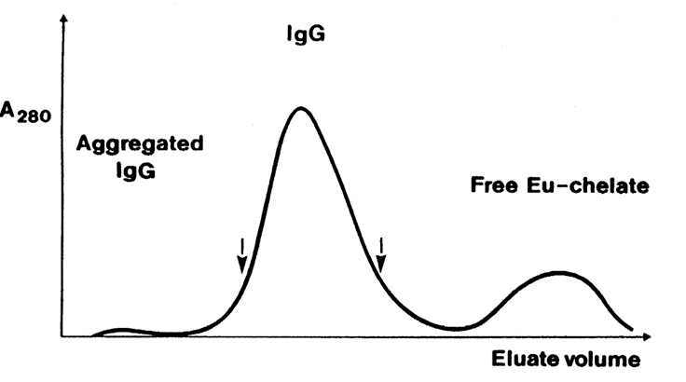

Figure 3: The elution profile of labelled IgG from a column of Sephadex G-50 and Sepharose 6B. The fractions between arrows (monomeric IgG) are recommended to be pooled.

When labelling only a small amount of antibody (< 0.5 mg) the purification can be done with a PD-10 column by applying the reaction mixture in the equilibrated column and collecting 0.5 mL fractions. The fractions from the first peak with the highest Eu counts should be pooled and characterized.

|  |  |
| --- | --- |
| Proteins MW above 100 000 | Proteins MW 30-100 000 |
| Superdex 200 | Superdex 75 |
| Sephadex G-50 /Sepharose 6B | Sephadex G-50 |

Table 2. Recommended columns for purification of proteins and peptides after labelling with Eu-N1 ITC chelate.

There should be dedicated columns for each lanthanide (europium, terbium, samarium, dysprosium) used for labelling. After purification, the gel filtration column should be decontaminated by washing with 10 mmol/L phthalate buffer (pH 4.1) containing 0.01 % DTPA. Before each run, it is advisable to saturate and further purify the gel filtration column on the previous day by applying concentrated BSA solution of high purity (e.g. 0.3 mL 7.5 % BSA; supplied with the kit). After adding the BSA the column should be equilibrated overnight. RP-HPLC columns can be washed using the phthalate buffer described above.

**CHARACTERIZATION OF LABELED PROTEINS AND PEPTIDES:**

Eu3+ Content: The exact concentration of Eu3+ after dilution with DELFIA Enhancement Solution (1:10 000 - 1:100 000), is calculated by measuring the fluorescence in microtitration strip wells (200 µL/well; in triplicates) and comparing to the fluorescence of 1 nmol/L Eu-standard (stock standard diluted 1:100 in Enhancement Solution) (1 nmol/L Eu in Enhancement Solution in a clear 96-well plate, 200 µL per well, gives about 1 000 000 cps when measured in 1234 DELFIA Research Fluorometer or 1420 VICTOR Multilabel Counter).

Protein Content: Protein concentration in the pooled fractions can be measured with appropriate methods, e.g. Lowry’s method, or it can be calculated from the protein absorbance at 280 nm. The molar absorptivity of reacted Eu-N1 ITC chelate is 8000 at 280 nm (1 µmol/L reacted chelate gives an absorbance of 0.008 at 280 nm).

Calculations: The following equations can be used for IgG. They are valid when the labelling yield is < 20 Eu3+/IgG. 1.34 is used for absorptivity value (for 1 mg/mL) of IgG, and 160 000 for MW.

**FILTRATION:**

To remove particles and possible aggregates the labelled protein should be filtered through a

0.22 µm low protein binding membrane.

**STORAGE OF LABELED COMPOUNDS:**

To ensure stability, the labelled proteins should be stored at a high concentration and in the absence of chelators or competing metals in the buffer. The stability can be increased by adding purified BSA (supplied with the kit) to a final concentration of 0.1 %. Temperature during storage is determined by the stability of the protein. Suitable temperatures are e.g. +4°C, -20°C and -70°C.

In cases where bovine albumin cannot be used as a carrier protein, the labelled proteins could be stored as such, if the protein concentration is over 100 µg/mL. If other proteins are used as carriers, these need to be purified from any heavy metal contaminations prior to addition. The carrier used also needs to be free from chelating agents.

**USE OF LABELED PROTEINS:**

Eu-labelled reagents can be applied in different types of assays based on solid-phase separation (e.g. competitive or non-competitive assays). The design of an assay depends on the analyte, the proteins, the possibility of using a sandwich-type assay or the need to employ a competitive assay-design, the required sensitivity and dynamic range etc.

As a general rule, about 25 - 100 ng of labelled proteins per well is enough for non-competitive sandwich-type assays, but the actual optimal level depends on the purity and affinity of the proteins and the desired signal levels. For competitive assays no general rules can be given and the assay always has to be separately optimized.

DELFIA Assay Buffer (supplied with the kit) is optimal for most assays.

**WARRANTY:**

The performance data presented here is obtained using the labelling procedure indicated and antibody solutions without interfering compounds. In the indicated conditions the labelling reagent is able to react with available free aminogroups of proteins. Change of buffers or variations in protein characteristics can cause alterations in the labelling reaction.

Purchase of this reagent gives the purchaser the right to use this material in his own research. Further distribution of this reagent or products resulting from its use is expressly prohibited. Purchase of this product implies agreement with these conditions of sale.

**PATENTS:**

The reagent is covered by patents on both the chemical structure and the dissociation enhancement principle (4,5).

1. Hemmilä, I. (1988): Lanthanides as probes for time-resolved fluorometric immunoassays. Scand. J. Clin. Lab. Invest. 48, 389-400.

2. Hemmilä, I., Dakubu, S., Mukkala, V.-M., Siitari, H. and Lövgren, T. (1984): Europium as a label in time-resolved immunofluorometric assays. Anal. Biochem. 137, 335-343.

3. Mukkala, V.-M., Mikola, H. and Hemmilä, I. (1989): The synthesis and use of activated N-benzyl derivatives of diethylenetriaminetetraacetic acids: Alternative reagents for labelling of antibodies with metal ions. Anal. Biochem. 176, 319-325.

4. Mikola, H., Mukkala, V.-M. and Hemmilä, I. (1987): Eur. Patent No. 139,675.

5. Mikola, H., Mukkala, V.-M. and Hemmilä, I. (1989): US Patent No. 4,808,541.

The information provided in this document is for reference purposes only and may not be all-inclusive. Revvity, Inc., its subsidiaries, and/or affiliates (collectively, “Revvity”) do not assume liability for the accuracy or completeness of the information contained herein. Users should exercise caution when handling materials as they may present unknown hazards. Revvity shall not be liable for any damages or losses resulting from handling or contact with the product, as Revvity cannot control actual methods, volumes, or conditions of use. Users are responsible for ensuring the product's suitability for their specific application. Revvity expressly disclaims all warranties, including warranties of merchantability or fitness for a particular purpose, regardless of whether oral or written, express or implied, allegedly arising from any usage of any trade or any course of dealing, in connection with the use of information contained herein or the product itself